|  |
| --- |
| Introduction to Simulation and Modeling |
| Homework 02 |
| Sand Pile Rule |

|  |
| --- |
| James Deromedi  3-22-2019 |

**Discussion**

My first initial hurtles to complete this homework was understanding how to manipulate in the inputted 3D array created from the .PNG. It wasn’t until coming to office hours that instead of manipulating the original array, instead create a new 2D array that allows for faster computations. Once I understand how to properly import the picture, completing the cases was easy. Under the suggestion to create a moving 2x2 window with, as Professor Knapp says, a ‘tick tock’ iteration through the array. While the cases could have been broken out into a function of there own so I did not have to repeat my code and could have abstracted the cases away into one, I choose to keep them as “if else” for the ease of understanding the code later.

There are two different probabilities within the cases, the first is the one given to us within the instructions. There is a variable that can be changed to create different chances, but I left it at 50%. The second deals with the edges of the hourglass. When there is an edge inside the window, the grain of sand touching the window has a higher probability to move that the grain of sand touch another grain of sand. I choose this parameter under the assumption that glass has less friction than sand.

Future work for this assignment could involve creating larger windows that iterate across, along the lines of the traffic simulation by looking at all the neighbors of a single grain. As well as, adding more parameters within the system like; static electricity holding sand together, wetness, different sized sand grains, and different levels of gravity.

**Input .PNGs**

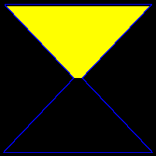

Figure 1: Original .PNG

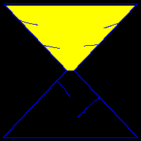

Figure 2: Hourglass with sloped lines on the edge

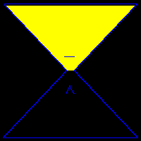

Figure 3: Hour glass with two blockers near the neck

**Original Hourglass**

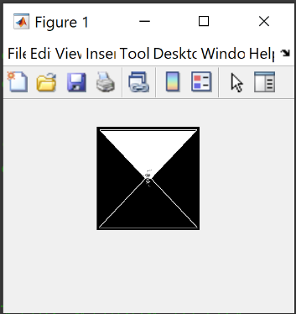

4: N = 10

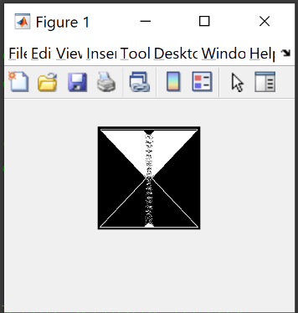

5: N = 100

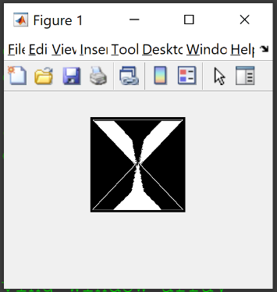

6: N = 1000

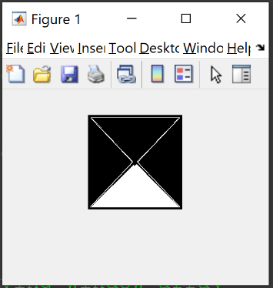

7: N = 10000

**Hourglass with Sloped Lines**

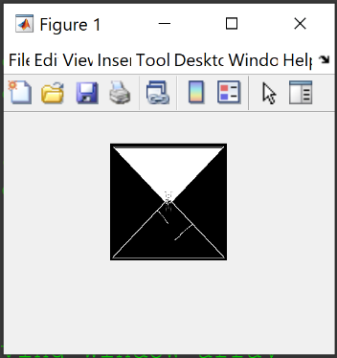

8: N = 10

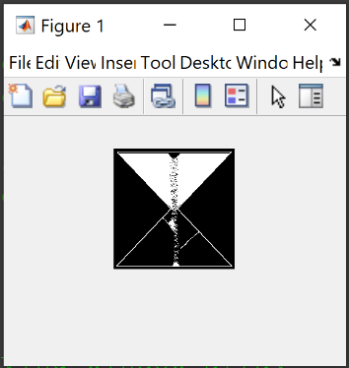

9: N = 100

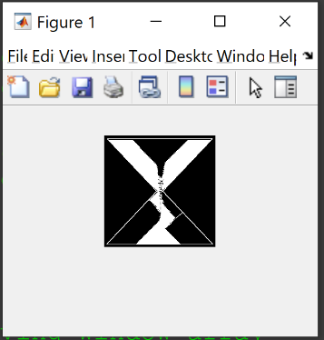

10: N = 1000

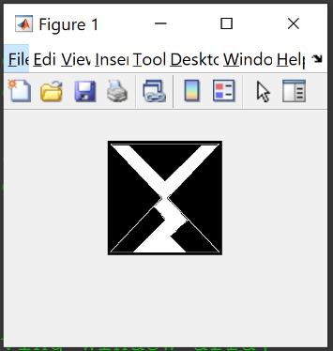

11: N = 10000

**Hourglass with Neck Breaks**

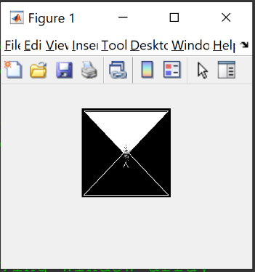

12: N = 10

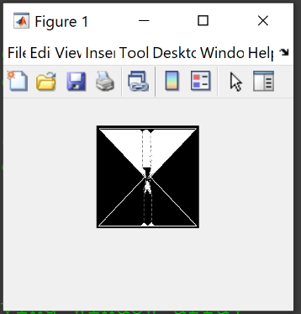

13: N = 100

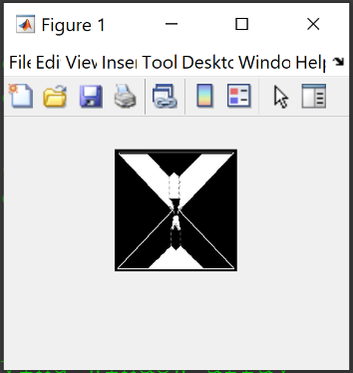

14: N = 1000

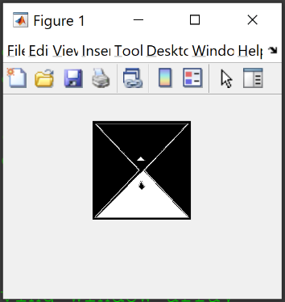

15: N = 10000